**COS30045 Data Visualization Lab Exercise (Lab 1.1 to Lab 2.4)**

Name: Chong Choon Meng

ID: 105562505

Github Link: <https://github.com/PastaKasta/CCM-COS30045>

Lab 1.1

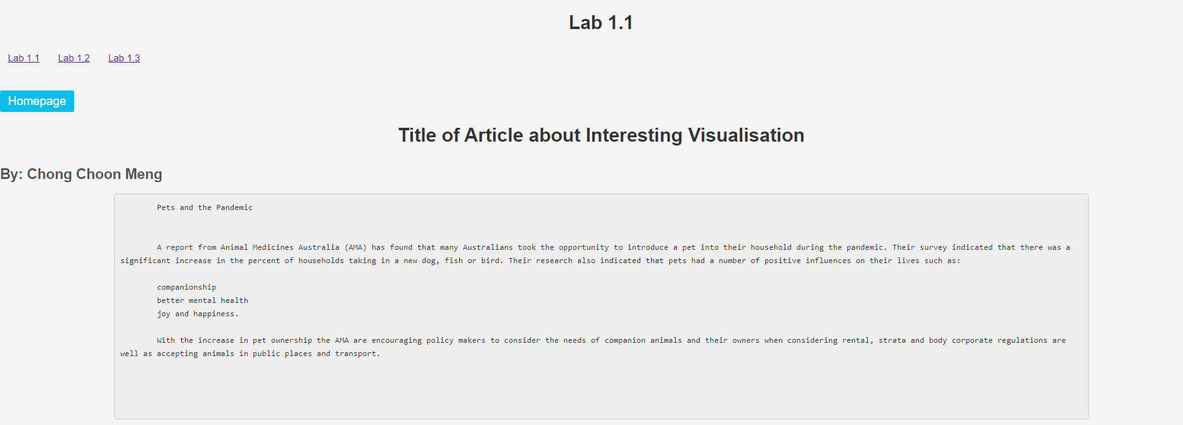



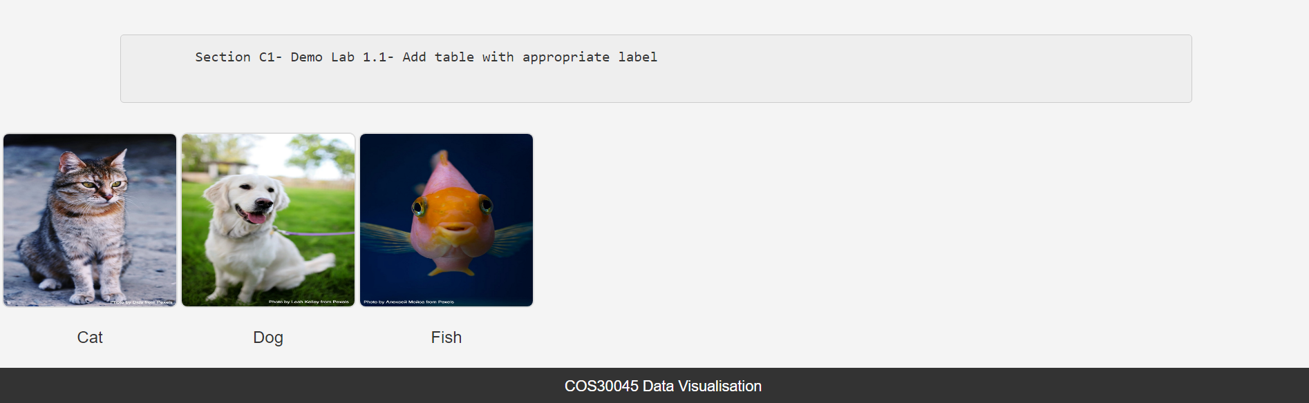

Lab 1.2

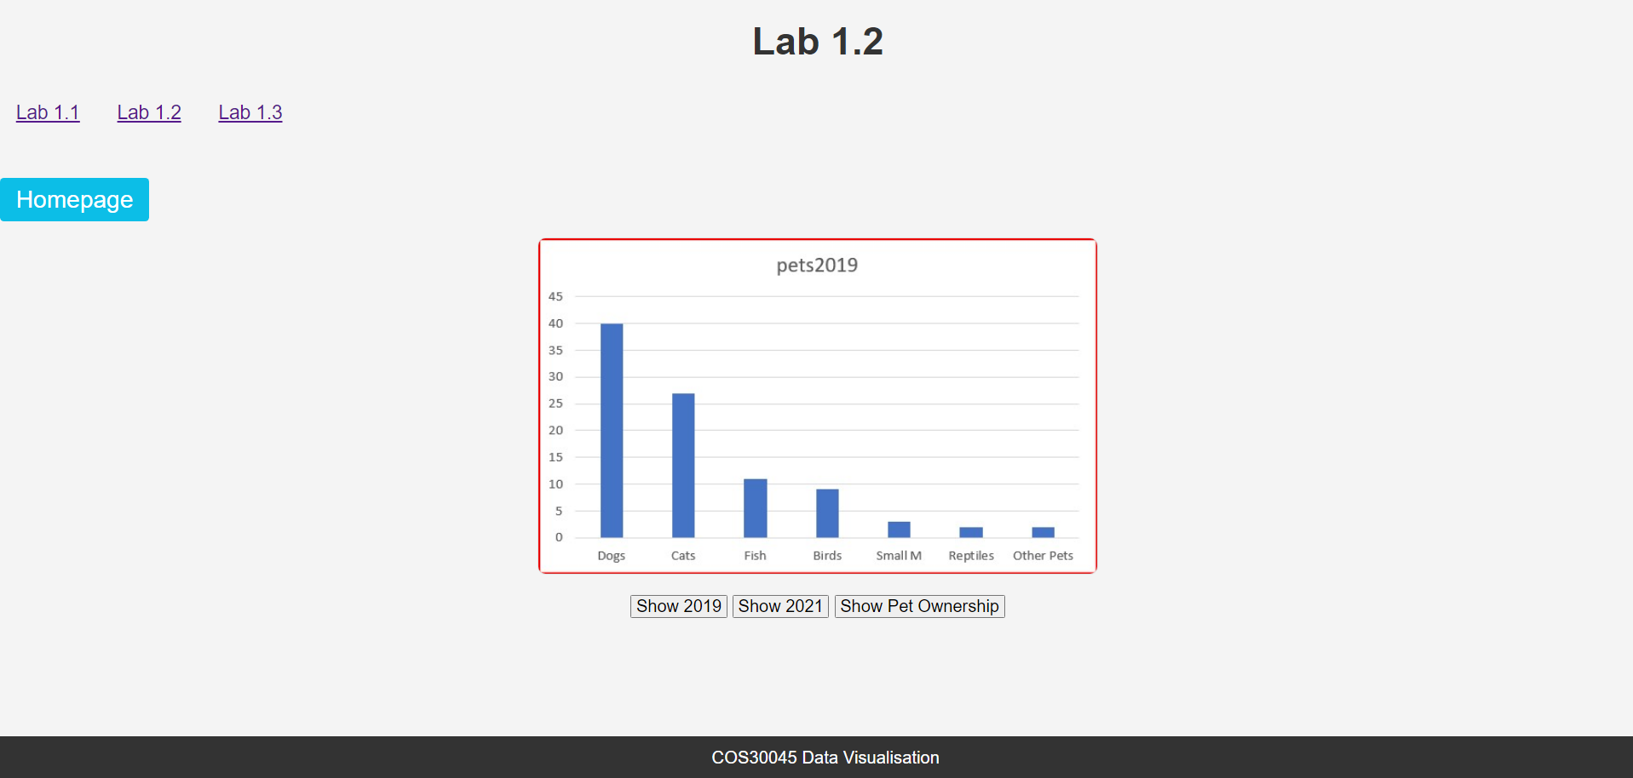

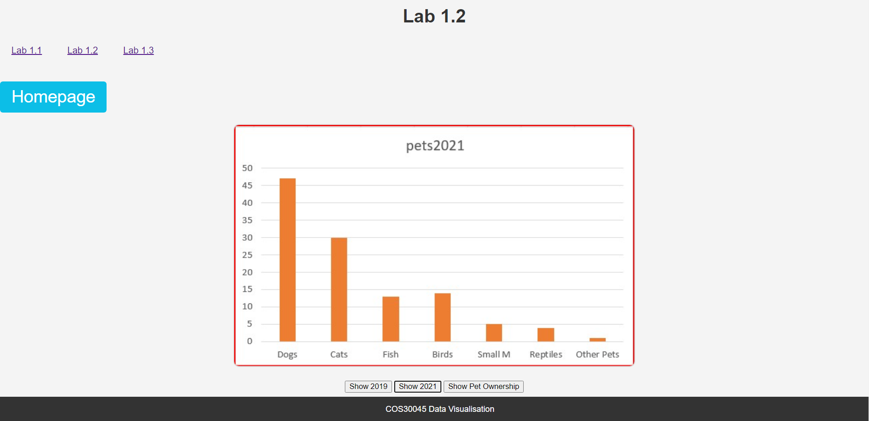

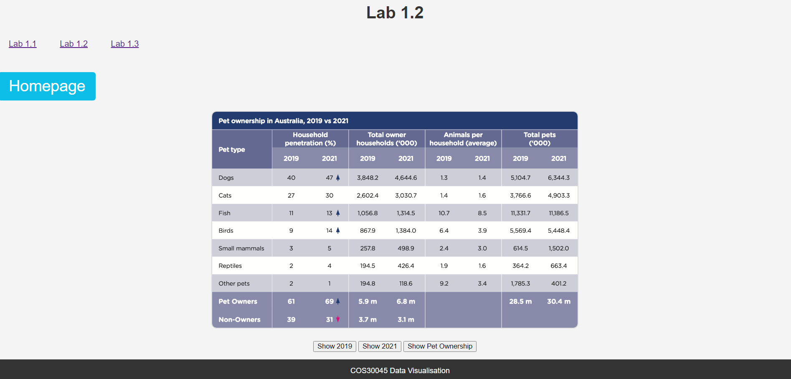

Lab 1.3

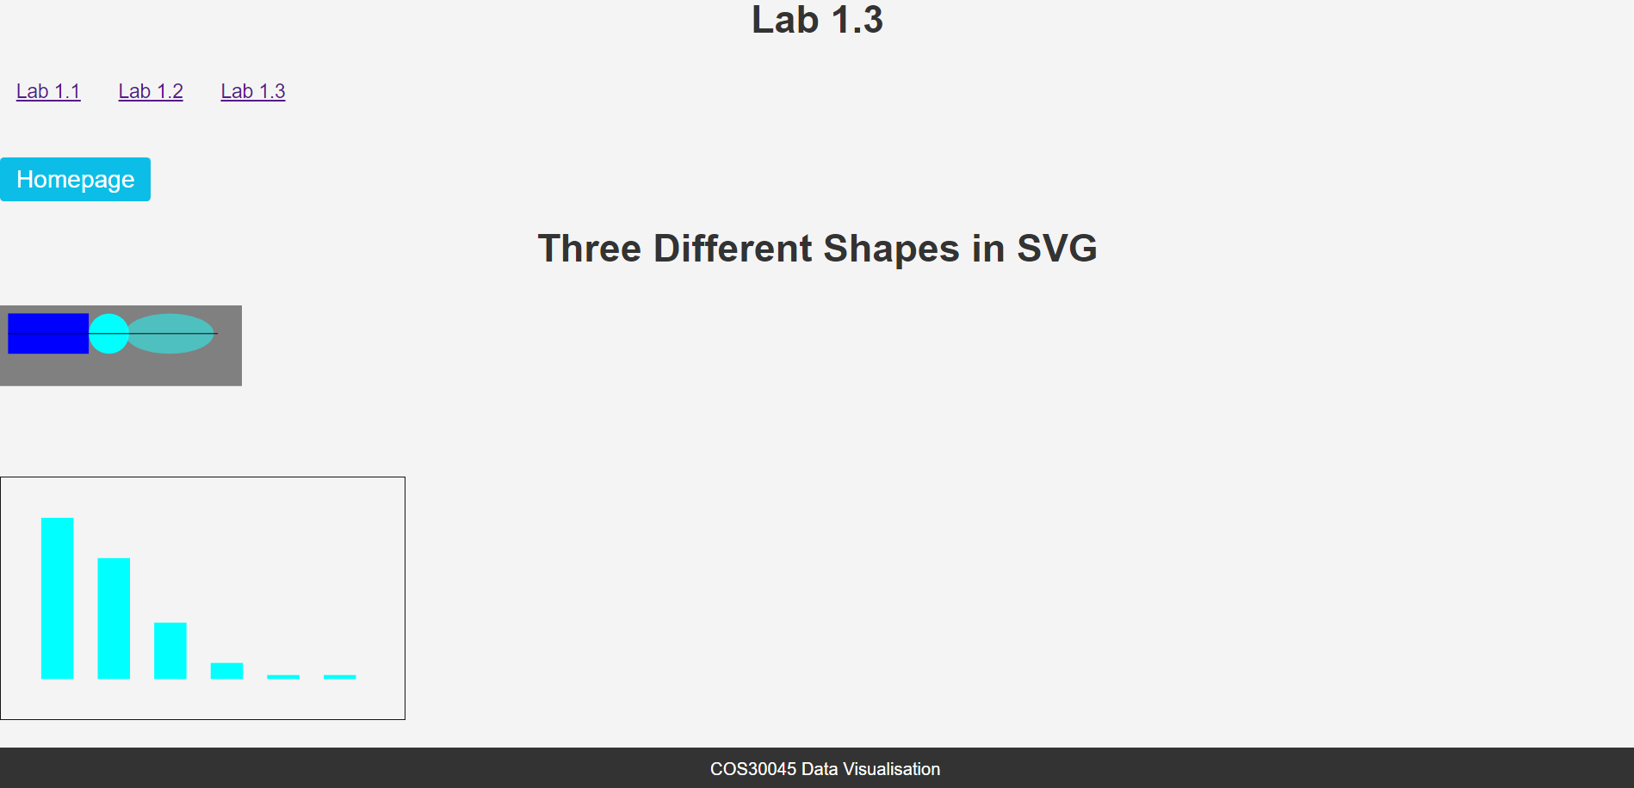

Lab 2.1

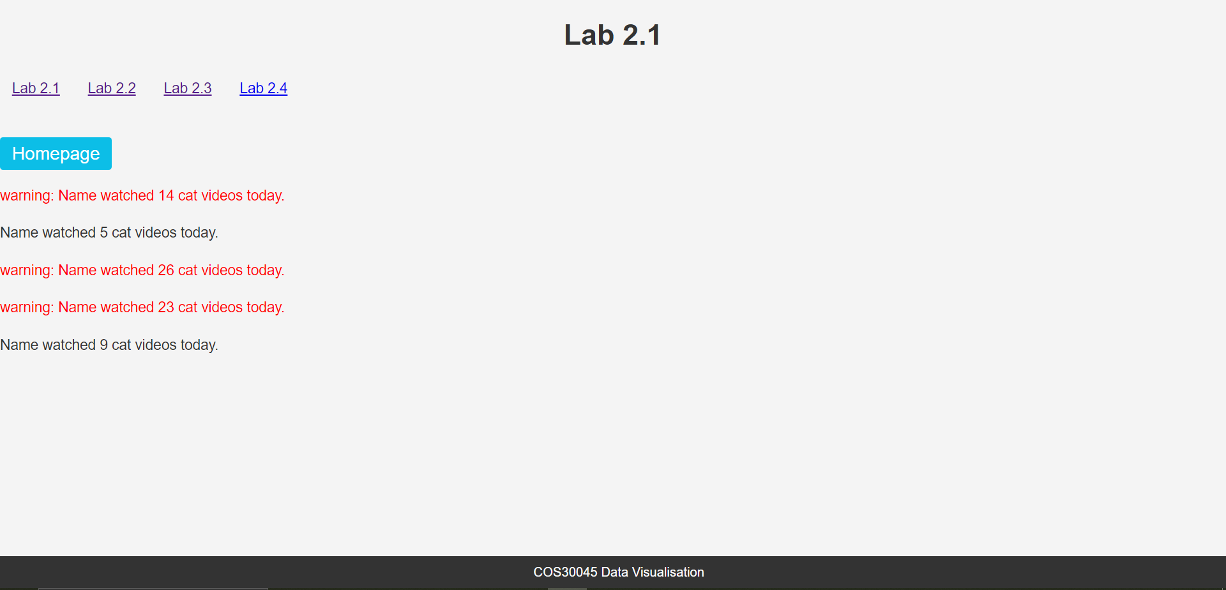

Lab 2.2

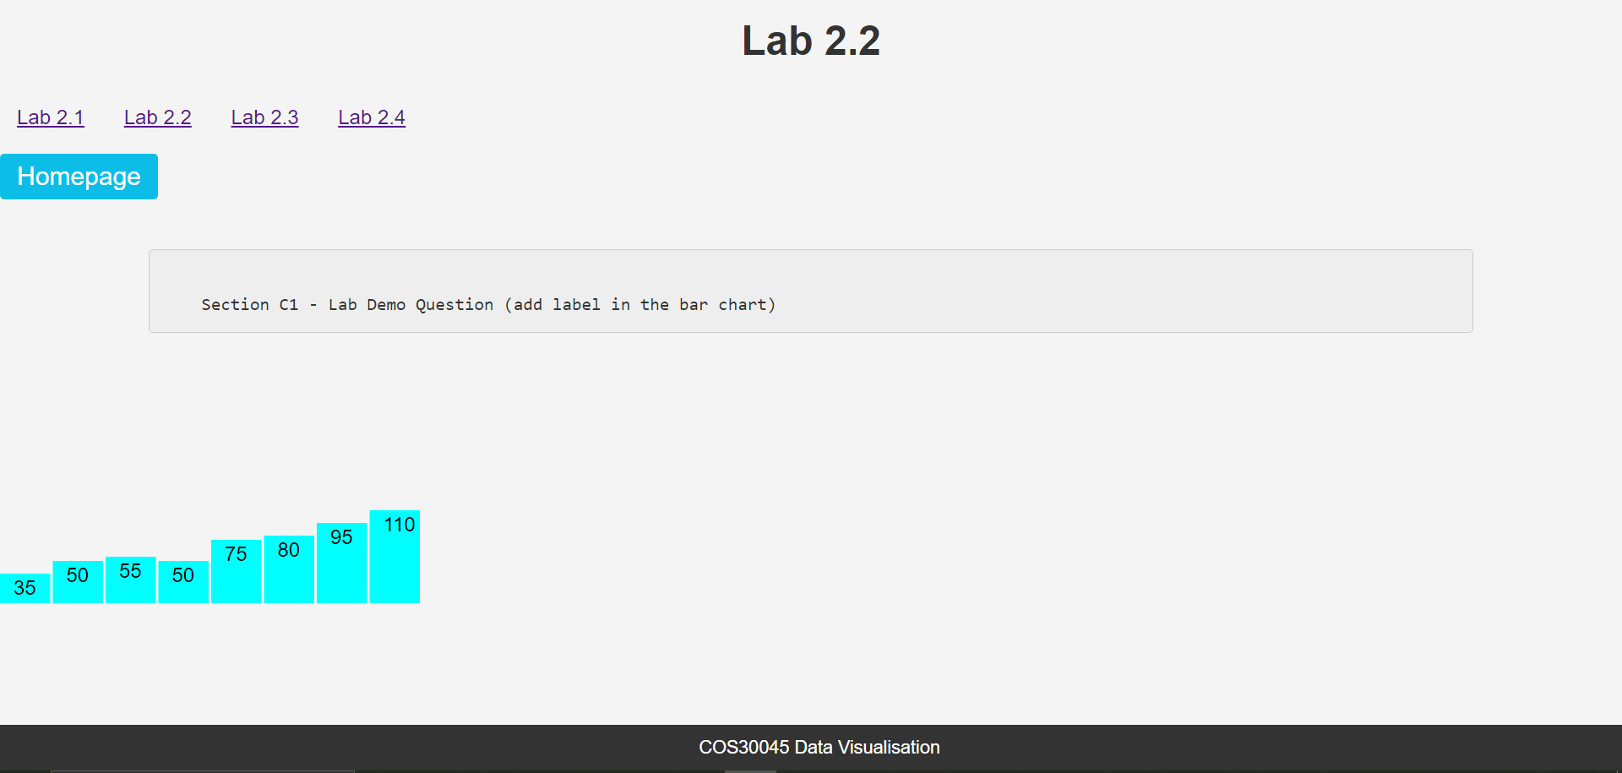

Lab 2.3

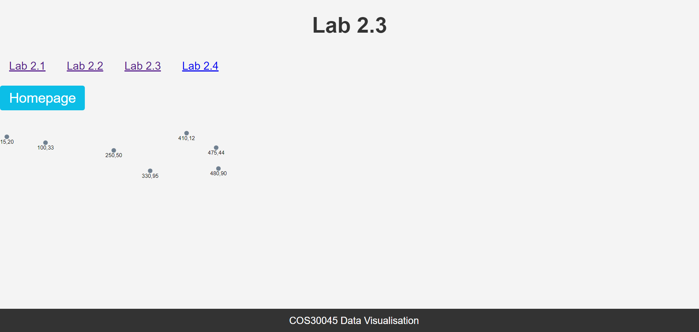

Lab 2.4

